PokeRacer UX report

This is a UX report for my application called PokeRacer

Contents

Home Screen 2

Practice 3

Race 4

Friends 5

# Introduction

The user experience is an important piece of any website. Is it intuitive, does it work, are there any unclarities. These are factors into having a good UX design. In this report I will show my designs first and after that I will be evaluating the designs with how other people experienced the website. I gave those people directions on what to do without telling them how to do it.

# Design

## Home Screen

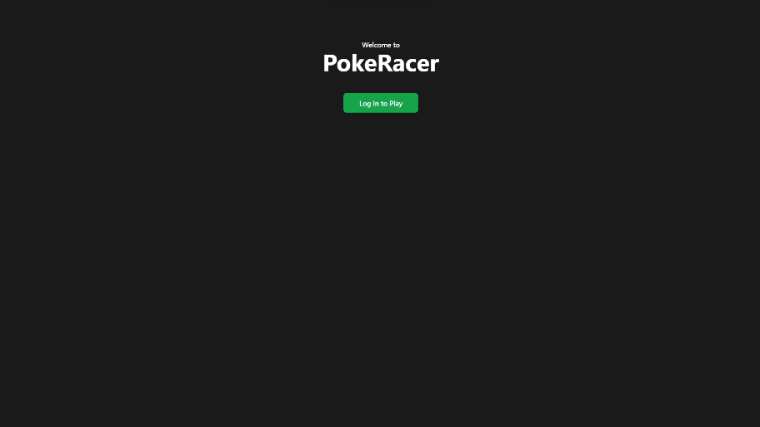Every website starts with a home screen, the first screen you’ll see when you go to a website. So it has to be clear what you have to do. When you haven’t logged into the application yet the homescreen just says “Welcome to PokeRacer”, with a green “Log In to Play” button to indicate that you have to login to do any further actions.

After logging in you have the Home Screen for people who are logged in. You can see that it looks different. That’s because it is, there is a Navbar and a Footer now, instead of “Welcome to PokeRacer” it now says “Hello {username}”. There are also 3 buttons right under the title, which point you to three different features of the website: Practice, Race and Friends. These three are also found up top in the navbar. These buttons might be double because they are both in the screen and in the navbar, but with the buttons being in the middle of the screen it’s more obvious what the user can do with the application.

## Navbar

Like stated before there is a navbar which, when logged in, is visible on every page of the application to go to different pages fast and easy. The navbar also shows your profile picture, your username and a logout button if you want to logout. Besides this you can notice on the picture of the navbar that you can see on which page you are based on the highlighted part in orange. So if you are on the “Home” page, the “Home” will be highlighted orange, on the “Practice” page “Practice is highlighted”, etc.



## Practice

When going to the practice tab you are shown the main gimmick of the website, guessing pokemon. In the top you can see the current time left, the score and your high score. On the right you can see the different generations of pokemon you can choose to guess and to the right you are able to set the time you want to take to guess.

## Race

When you go to the race tab you are immediatly welcomed with 2 lists. One of the lists shows your friends which you can invite to race with. The other list shows people who have currently invited you to a race, and by pressing the green “Accept” button you can accept that race request and start the race.

When selecting a friend to invite, you get presented with a box where you can select a generation and time limit for the race. After selecting the generation and time you can press the green “Invite” button and an invitation will be sent to the selected friend.

## Friends

When going to the friends page. The first thing you’ll see is a list of friends at the left of the screen. While friends are show with a grey background and a blue button, you can also see the friend invites in blue above your current friend list, where you can accept the friend requests.

Upon acceptig the friend request the friend is instantly shown in the current friendlist

When selecting a friend the selected friend turns from grey to green, and you will be able to see a red remove friend button to remove a friend.

After doing so the friend will be deleted from the friendlist and will be removed as your friend.

When the friend is selected you are also to see the a chat with the person you have selected. In the chat there is an input box which allows you to type your message and by pressig enter or the send button. For every message you’ve sent will show up for you as green and on the right. Any message the other person sent will be shown as grey and on the left side of the chatbox.

# Feedback

I gave some people a set of instructions to follow when using my application. These were:

1. Make an account (sign up) and remember the email and password
2. Add [test@test.test](mailto:test@test.test) as a friend.
3. Alt Tab to another instance of the website (which is logged in as [test@test.test](mailto:test@test.test)) to accept the friend
4. Go back to the original page where you were first.
5. Send a chat message to [test@test.test](mailto:test@test.test)
6. Log out
7. Log back in
8. Practice guessing pokemon, set a generation and time of choice.

I ended up having a few people walk through my application with these instructions. All of them were able to complete the tasks, but a few of them got stuck at 5) Send a chat message. Where they were looking for a chat when they had to select the user first. They did figure it out on their own without help but it just took them a bit longer than the rest of my testers. Also none of them knew any pokemon so they couldn’t guess any, but that is not a UX problem.

Even though most of them got through it flawlessly does not mean it’s great UX. I asked them what I should change (not counting style / looks) to enhance the experience. One of the answers was when going to practice pokemon the choice for the Time / Generation are far on the sides of the screen and a bit out of the way. This could make it annoying to move the mouse to the other side of the screen or maybe just a bit missable. Another point my testers made was to maybe have the chat there at all times, and just say select a friend to change the chat to the person you want to chat with, that way it makes it more obvious that there actually is a chat feature.

# Usability Heuristics

The usability heuristics were created by Jakob Nielsen which are simply said a rule of thumb you should follow for a good User Interface. In this report I will also compare my application with the Heuristics.

## 1 – Visibility of system status

“**The design should always keep users informed about what is going on, through appropriate feedback within a reasonable amount of time.**”

Showing on what page the user is falls under this topic. Which I do as you could see at the navbar header on page 4 of this report.

## 2 – Match between system and real world

“**The design should speak the users' language. Use words, phrases, and concepts familiar to the user, rather than internal jargon. Follow real-world conventions, making information appear in a natural and logical order.**”

Some things that might fall under this category is the use of icons. I’m not using icons because I don’t think it really fits the looks of the website. Also what falls under this is what was explained at my feedback. That the chat was kind-off hidden and wasn’t well known on how to get to. This would probably be one of the focus points to improve inside of my application.

## 3 – User control and freedom

“Users often perform actions by mistake. They need a clearly marked "emergency exit" to leave the unwanted action without having to go through an extended process.”

A few tips given under this heuristic are: Have a undo/redo button, Show a clear way to cancel an interaction, like a cancel button and make sure the exit is clearly labeled and discoverable. Now in my practice mode when playing, there is’t a real way to stop it except close the page or go to another page of the website. I think making a stop or give up button whilst practicing might be a great way to show that you are able to stop after you’ve started.

## 4 – Consistency and Standards

“Users should not have to wonder whether different words, situations, or actions mean the same thing. Follow platform and industry conventions.”

One example of this being is that everywhere the button combination: “Control + C” means copy, but inside of your application it means cut or paste. That’s not following insdustry conventions. I think I don’t have anything that might be found as not fitting inside of the industry conventions.

## 5 – Error prevention

“Good error messages are important, but the best designs carefully prevent problems from occurring in the first place. Either eliminate error-prone conditions, or check for them and present users with a confirmation option before they commit to the action.”

There are 2 types of errors: Slips and Mistakes. While Slips are errors made by inattention. Mistakes are made because someones mental images was different than from the design. I haven’t found any possible errors that could happen in the UX without being handled, so in that case I don’t think that there is any more to say on this subject.

## 6 – Recognition rather than recall

“Minimize the user's memory load by making elements, actions, and options visible. The user should not have to remember information from one part of the interface to another. Information required to use the design (e.g. field labels or menu items) should be visible or easily retrievable when needed.”

The humans short term memory isn’t the greatest, so it’s better that someone recognizes something instead of having to remember how they did it. I think this also falls back on the chat selecting problem I mentioned earlier. Because it is out of the way people have to recall that there is a chat function instead of just being able to see the chat.

## 7 – Flexibility and efficiency of use

“Shortcuts — hidden from novice users — may speed up the interaction for the expert user so that the design can cater to both inexperienced and experienced users. Allow users to tailor frequent actions.”

I don’t think the shortcuts are able to apply to my application except for something like pressing enter to send a message. Customization might be a feature that should be implemented but isn’t. In the future that might be a possible feature.

## 8 – Aestetic and minimalist design

“Interfaces should not contain information that is irrelevant or rarely needed. Every extra unit of information in an interface competes with the relevant units of information and diminishes their relative visibility.”

This kind off goes back to the fact that during practice modes, that the generation and timelimit choice are far apart to the sides of the screen and when you don’t notice them you don’t know that they are able to be changed.

## 9 – Help users recognize, diagnose and recover from errors

“Error messages should be expressed in plain language (no error codes), precisely indicate the problem, and constructively suggest a solution.”

This is like instead of saying 404, it’s more like saying “404, page not found” or even “The page you were looking for does not exist”. Because not every user is going to know what error code 404 is, or error code 500. I do have a 404 page saying “404” page not found.

## 10 – Help and documentation

“It’s best if the system doesn’t need any additional explanation. However, it may be necessary to provide documentation to help users understand how to complete their tasks.”

This could be the FAQ section or just any documentation. Just like how APIs have documentation on how to use them or like Github which has documentation on how to use Git. I don’t think this will apply to my application just yet, maybe once it grows larger.